Agent

1. Add field for Agent_Bio, varchar, 1000
2. Include in Edit Agent

Listing

1. Remove the following from screen, comment out in the code, leave in the database for possible future use.
   1. Basement
   2. Exterior
   3. MobileListing Template
2. Make Bedrooms and Bathrooms a drop down selector
   1. Bedrooms ( whole numbers 1-10)
   2. Bathrooms (1, 1.5, 2, 2.5 …10)
   3. Validate Zip as 5 digit numeric
   4. All fields are required

Account

1. New field in account table
   1. OwnerAgent, tiny int (1=owner, 2=agent)
2. Only visible in Edit Account and Account info if account type is RE
3. Logic for setting value at time of sign up ( processing after the successful payment)
   1. If account type RE
      1. If recurrence = 0 then owneragent=1
      2. Else owneragent =2
4. Screen shot example  
   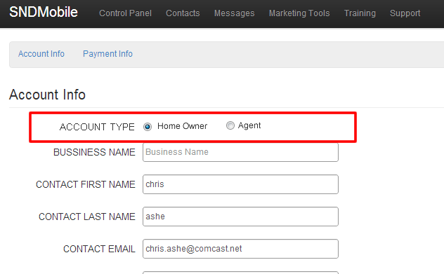

Mobile Listing Site Link

The icon link for mobile listing in the Codes screen table and Listings screen table need to change based on value of owneragent field

1. If owneragent=1 then link = <http://sndmobile.com/app/mobile/1/listing.php?id=13>
2. If owneragent=2 then link = <http://sndmobile.com/app/mobile/2/listing.php?id=13>

Mobile Site

1. For now, just copy the mobile code in the /1 directory over to the /2 directory so that we have 2 versions.
2. Remove the header in the /1 version just so there is a visual difference in the two mobile sites.
3. I am working on the new mobile site versions for /1 and /2 but do not have them ready yet.

QR – RE

1. Add field to Listing table
   1. QRImage1, varchar 128
   2. QRImage2, varchar 128
   3. QRImage3, varchar 128
2. Auto generate QR for each property
   1. Target url = mobile listing site
   2. Sizes
      1. Image1 = 100x100
      2. Image2 = 200x200
      3. Image 3 = 300x300
3. Add QR icon in actions column on Codes Table (RE Dashboard Screen) & Listings Screen Table
   1. See NewControlPanelQR.png screen shot example
4. On click, pop modal with full size QR
   1. screen shot example  
      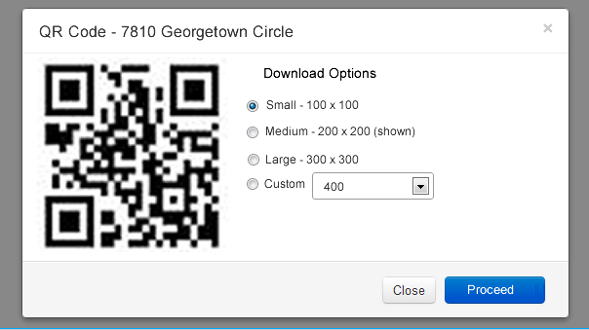
   2. when user clicks proceed, download the image to their computer.